Report

Team members:

Ahmed Ezzat | 202402481
Rofida Ramadan | 202201888
Mariam Samir | 202200562

Step 1: Data Cleaned Loading

Loading data from CSV File
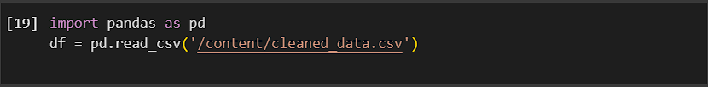

Step 2: Data Encryption
Used Caesar Cipher encryption on sensitive text columns in order to maintain confidentiality:
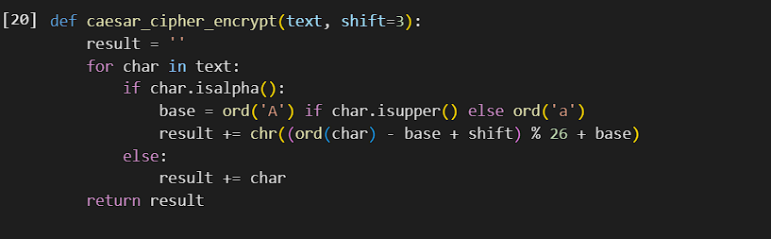

Encrypted columns: city, region, type.
Each character was shifted three positions, which was the value used for this operation.

Step 3: Privacy Policies and Access Control
- Users are assigned roles: admin, user, or guest.

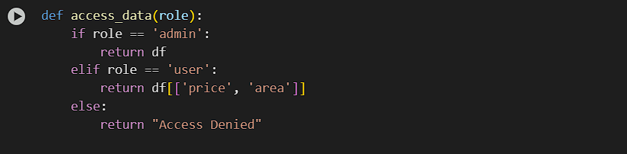
- Admin: Full access to all columns.

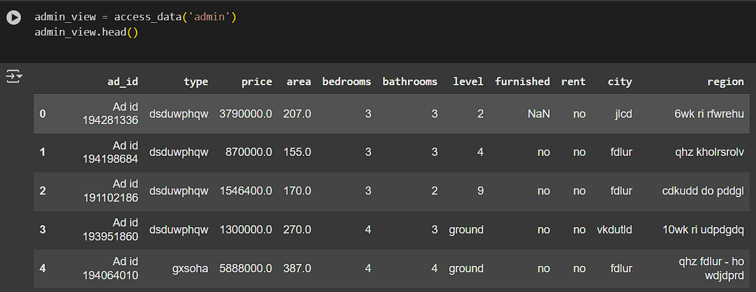

- User: Limited access to price and area columns only.
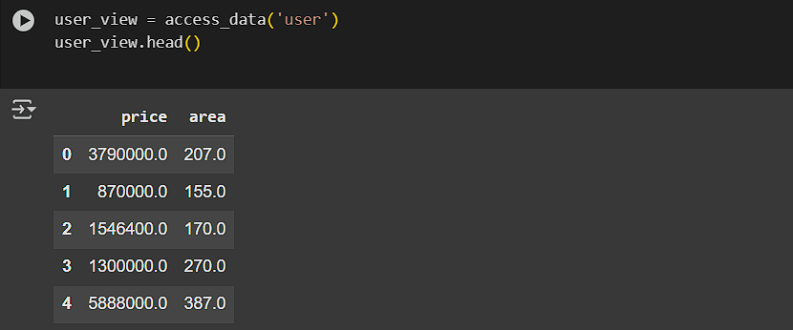

- Guest: Access denied

Step 4: Data Security Measures
- Hashing (Optional for future work): Should the need arise, numeric IDs could be hashed.
- Encrypted Data saved into a new file:

Step 5: Compliance with Data Protection Regulations
Sensitive textual attributes (city, region, type) were encrypted with the Caesar Cipher algorithm in order to make the data anonymous and undisclosed.

Role-Based Access Control (RBAC) was implemented in order to restrict access to specific fields of data based on the role assigned to the user.

Only authorized users (Admins) can access all columns of data, while normal users only see non-sensitive fields.

These privacy and security controls ensure confidentiality, integrity, and restricted accessibility of the dataset.

The procedures applied are consistent with fundamental data protection principles as provided by laws such as GDPR and CCPA.

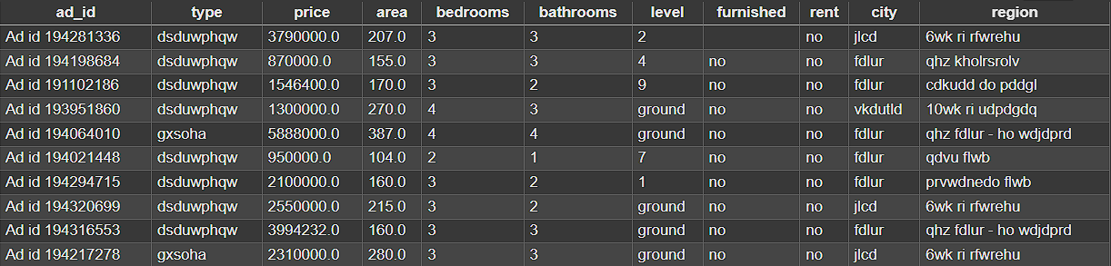

Summary:
Sensitive columns encrypted.

Role-based access established and enforced.

Dataset ready for further secure processing and analysis.

Final encrypted dataset and access control policies successfully deployed.

